Algebra 2 Unit 5 Notes: 5.3 Solving Square Root Equations

Radicals can be written with rational exponents:
$\sqrt{x}$ can be written as $x^{\frac{1}{2}}$

Convert to rational exponent form. Convert to radical form.
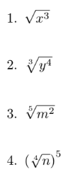
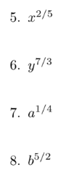

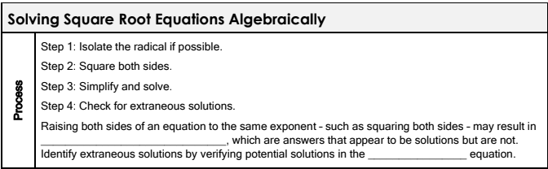
Examples: Solve the following equations. Check for extraneous solutions.

1. $\sqrt{3x+5}=7$ CHECK 2. $3x^{\frac{1}{2}}=6$ CHECK

3. $4\sqrt{2x-3}=16$ CHECK 4. $\sqrt{x+4}=12$ CHECK

5. ${\left(9x-4\right)}^{\frac{1}{2}}={{\left(7x-20\right)}^{\frac{1}{2}}}^{}$ CHECK

6. $\sqrt{12-x}=\sqrt{x+6}$ CHECK

7. ${\left(11x+3\right)}^{\frac{1}{2}}-2x=0$ CHECK

8. $\sqrt{3x+13}-5=x$ CHECK

9. $\sqrt{x+18}=x-2$ CHECK

10. $\sqrt{x+10}+\sqrt{3-x}=5$ CHECK

11. ${\left(3x-5\right)}^{\frac{1}{2}}-{\left(2x+3\right)}^{\frac{1}{2}}+1=0$ CHECK

